1. BANK LOAN REPORT | SUMMARY

KPI’S:

* Total Loan Application

1. 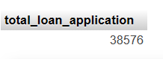Total Loan Applications

SELECT COUNT(id) as ‘total_loan_application’

FROM bank_loan;

1. 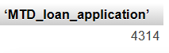MTD loan Applications

SELECT COUNT(id) as ‘total_loan_application’

FROM bank_loan

WHERE MONTH(issue_date)=12 AND YEAR(issue_date)=2021

1. 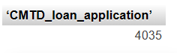PMTD loan Applications

SELECT COUNT(id) as ‘total_loan_application’

FROM bank_loan

WHERE MONTH(issue_date)=11 AND YEAR(issue_date)=2021

* Total Funded Amount

1. 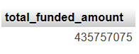Total Funded Amount

SELECT SUM(loan_amount) as 'total_funded_amount'

FROM `bank_loan`

1. MTD Total Funded Amount

SELECT SUM(loan_amount) as 'MTD_total_funded_amount'

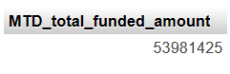FROM `bank_loan`

WHERE MONTH(issue_date)=12 AND YEAR(issue_date)=2021

1. PMTD Total Funded Amount

SELECT SUM(loan_amount) as 'PMTD_total_funded_amount'

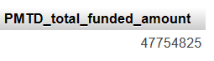FROM `bank_loan`

WHERE MONTH(issue_date)=11 AND YEAR(issue_date)=2021

* Total Amount Received

1. Total Amount Received

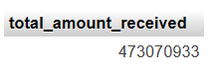SELECT SUM(total_payment) as 'total_amount_received'

FROM `bank_loan`

1. MTD Total Amount Received

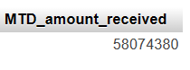SELECT SUM(total_payment) as 'MTD_amount_received'

FROM `bank_loan`

WHERE MONTH(issue_date)=12 AND YEAR(issue_date)=2021

1. PMTD Total Amount Received

SELECT SUM(total_payment) as 'PMTD_amount_received'

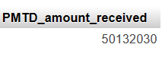FROM `bank_loan`

WHERE MONTH(issue_date)=11

AND YEAR(issue_date)=2021

* Average Interest Rate

1. . Average Interest Rate

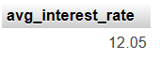 SELECT ROUND((AVG(int_rate)*100),2) as 'avg_interest_rate'

FROM bank_loan

1. . MTD Average Interest Rate

SELECT ROUND((AVG(int_rate)*100),2) as 'MTD_avg_interest_rate'

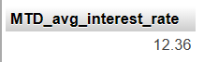FROM bank_loan

WHERE MONTH(issue_date)=12 AND YEAR(issue_date)=2021

1. . PMTD Average Interest Rate

SELECT ROUND((AVG(int_rate)*100),2) as 'PMTD_avg_interest_rate'

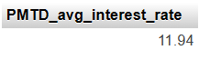FROM bank_loan

WHERE MONTH(issue_date)=11 AND YEAR(issue_date)=2021

* Average Depth-to-Income Ratio(DTI)

1.  Average DTI

SELECT ROUND((AVG(dti)*100),2) as 'avg_DTI'

FROM bank_loan

1. MTD Average DTI

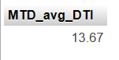SELECT ROUND((AVG(dti)*100),2) as 'avg_DTI'

FROM bank_loan

WHERE MONTH(issue_date)=12 AND YEAR(issue_date)=2021

1. 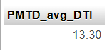 PMTD Average DTI

SELECT ROUND((AVG(dti)*100),2) as 'PMTD_avg_DTI'

FROM bank_loan

WHERE MONTH(issue_date)=11 AND YEAR(issue_date)=2021

GOOD LOAN ISSUED:

1. Good Loan Percentage

SELECT

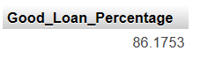COUNT(CASE WHEN loan_status= 'Fully Paid' OR

loan_status= 'Current'

THEN id END) *100 / COUNT(id) as 'Good_Loan_Percentage'

FROM bank_loan

1. 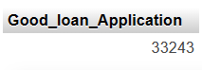Good Loan Application

SELECT COUNT(id) as "Good_loan_Application"

FROM bank_loan

WHERE loan_status="Fully Paid" OR loan_status="Current";

1. Good Loan Funded Amount

SELECT SUM(loan_amount) as "Good_loan_funded_amount"

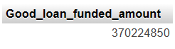FROM bank_loan

WHERE loan_status="Fully Paid" OR loan_status="Current"

1. Good Loan Amount Received

SELECT SUM(total_payment) as "Good_loan_amount_received"

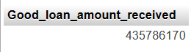FROM bank_loan

WHERE loan_status="Fully Paid" OR loan_status="Current"

BAD LOAN ISSUED:

1. Bad Loan Percentage

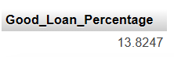SELECT

COUNT(CASE WHEN loan_status="Charged Off"

THEN id END) *100 / COUNT(id) as'Bad_Loan_Percentage'

FROM bank_loan

1. Bad Loan Application

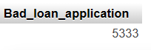SELECT COUNT(id) as "Bad_loan_application"

FROM bank_loan

WHERE loan_status="Charged Off"

1. Bad loan Funded Amount

SELECT SUM(loan_amount) as 'Bad_loan_funded_amount'

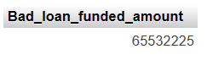FROM bank_loan

WHERE loan_status="Charged Off"

1. Bad loan Amount Received

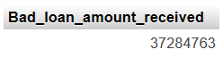SELECT SUM(total_payment) as 'Bad_loan_amount_received'

FROM bank_loan

WHERE loan_status="Charged Off"

LOAN STATUS:

SELECT loan_status, COUNT(id) as "total_loan_application",

SUM(total_payment) as "total_amount_received",

SUM(loan_amount) as "total_funded_amount",

ROUND(AVG(int_rate)*100,2) as "avg_intrest_rate",

ROUND(AVG(dti)*100,2) as "avg_dti"

FROM bank_loan

GROUP BY loan_status;

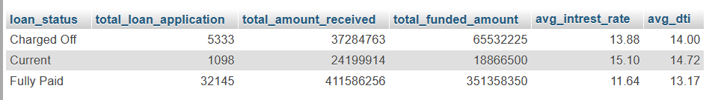

1. BANK LOAN REPORT | OVERVIEW

CHARTS

1. MONTH

SELECT MONTH(issue_date) AS 'month_number',

MONTHNAME(issue_date) as 'month_name',

COUNT(id) as 'total_loan_applications',

SUM(loan_amount) as 'total_funded_amount',

SUM(total_payment) as 'total_loan_received'

FROM bank_loan

GROUP BY MONTH(issue_date), MONTHNAME(issue_date)

ORDER by MONTH(issue_date);

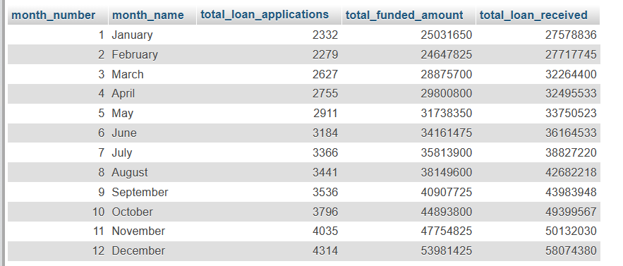

1. STATE

SELECT address_state as 'state',

COUNT(id) as 'total_loan_applications',

SUM(loan_amount) as 'total_funded_amount',

SUM(total_payment) as 'total_loan_received'

FROM bank_loan

GROUP BY address_state

ORDER by address_state;

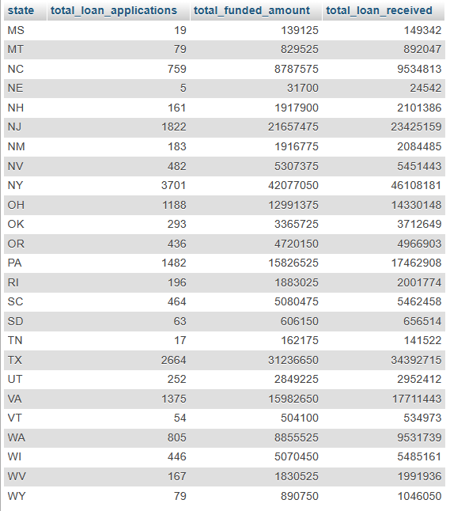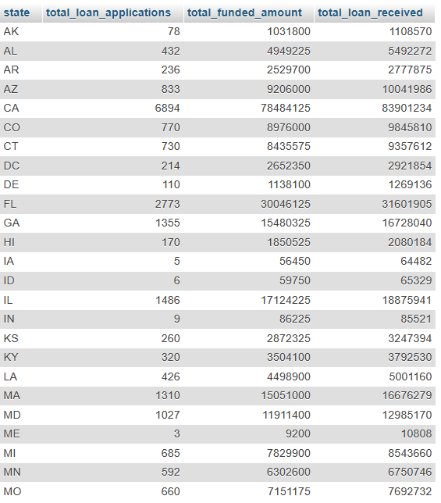

1. TERM

SELECT term ,

COUNT(id) as 'total_loan_applications',

SUM(loan_amount) as 'total_funded_amount',

SUM(total_payment) as 'total_loan_received'

FROM bank_loan

GROUP BY term

ORDER by term;

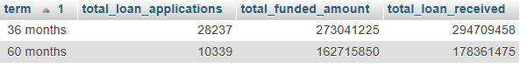

1. EMPLOYEE LENGTH

SELECT emp_length ,

COUNT(id) as 'total_loan_applications',

SUM(loan_amount) as 'total_funded_amount',

SUM(total_payment) as 'total_loan_received'

FROM bank_loan

GROUP BY emp_length

ORDER by emp_length;

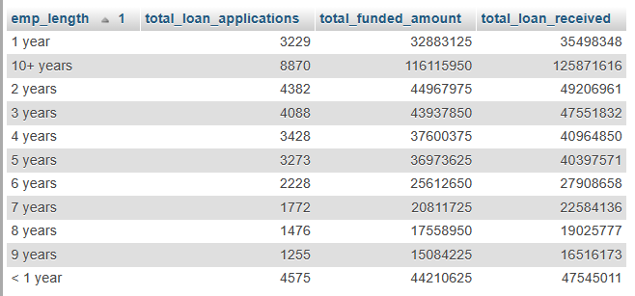

1. PURPOSE

SELECT purpose ,

COUNT(id) as 'total_loan_applications',

SUM(loan_amount) as 'total_funded_amount',

SUM(total_payment) as 'total_loan_received'

FROM bank_loan

GROUP BY purpose

ORDER by COUNT(id) DESC;

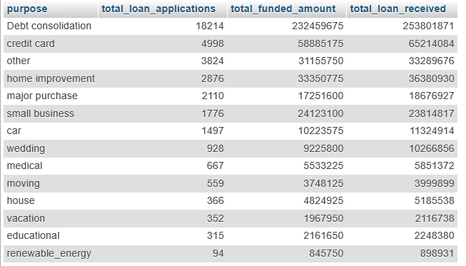

1. HOME OWNERSHIP

SELECT home_ownership ,

COUNT(id) as 'total_loan_applications',

SUM(loan_amount) as 'total_funded_amount',

SUM(total_payment) as 'total_loan_received'

FROM bank_loan GROUP BY home_ownership

ORDER by COUNT(id) DESC

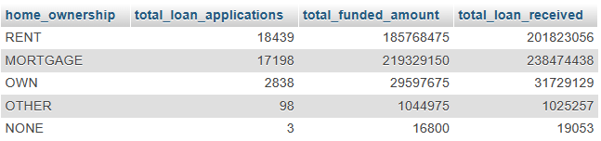

*“Note: We have applied multiple Filters on all the dashboards. You can check the results for the filters as well by modifying the query and comparing the results.”*

*For e.g*

*See the results when we hit the Grade A in the filters for dashboards.*

*SELECT*

*purpose AS PURPOSE,*

*COUNT(id) AS Total_Loan_Applications,*

*SUM(loan_amount) AS Total_Funded_Amount,*

*SUM(total_payment) AS Total_Amount_Received*

*FROM bank_loan_data*

*WHERE grade = 'A'*

*GROUP BY purpose*

*ORDER BY purpose*